Report
Gao Yuyang

Abstract

The purpose of this simulation program is to understand the impact of initial vampire populations on the rate of infection among humans. The program uses a combination of object-oriented programming and mathematical modeling to simulate the spread of vampire infection among a population of humans. The simulation was run with different initial vampire populations, ranging from 1 to 10, and the results were analyzed to understand the relationship between the initial vampire population and the rate of human infection.

Background

Vampires have become a major concern for humanity, as their existence threatens the survival of the human race. In order to overcome this threat, it is crucial to understand the dynamics of vampire infection among humans. This simulation program was developed to investigate the impact of initial vampire populations on the rate of human infection. The program was designed to answer the following questions: How does the initial vampire population affect the rate of human infection? Are there any situations where all humans do not become vampires?

Methodology

The simulation program was implemented using the Python programming language. The program consists of three main components: A2.py, popSweep.py, and characters.py. A2.py is the main script that runs the simulation, popSweep.py is used to perform a parameter sweep, and characters.py contains the definition of the vampire and human classes. The program was run with different initial vampire populations, ranging from 1 to 10, and the results were analyzed to understand the relationship between the initial vampire population and the rate of human infection.

To run the simulation, the following command was used:

python3 A2.py <initial_human_population> <initial_vampire_population>

To perform the parameter sweep, the following command was used:

bash popSweep.sh <low_human_population> <high_human_population> <low_vampire_population> <high_vampire_population>

Results
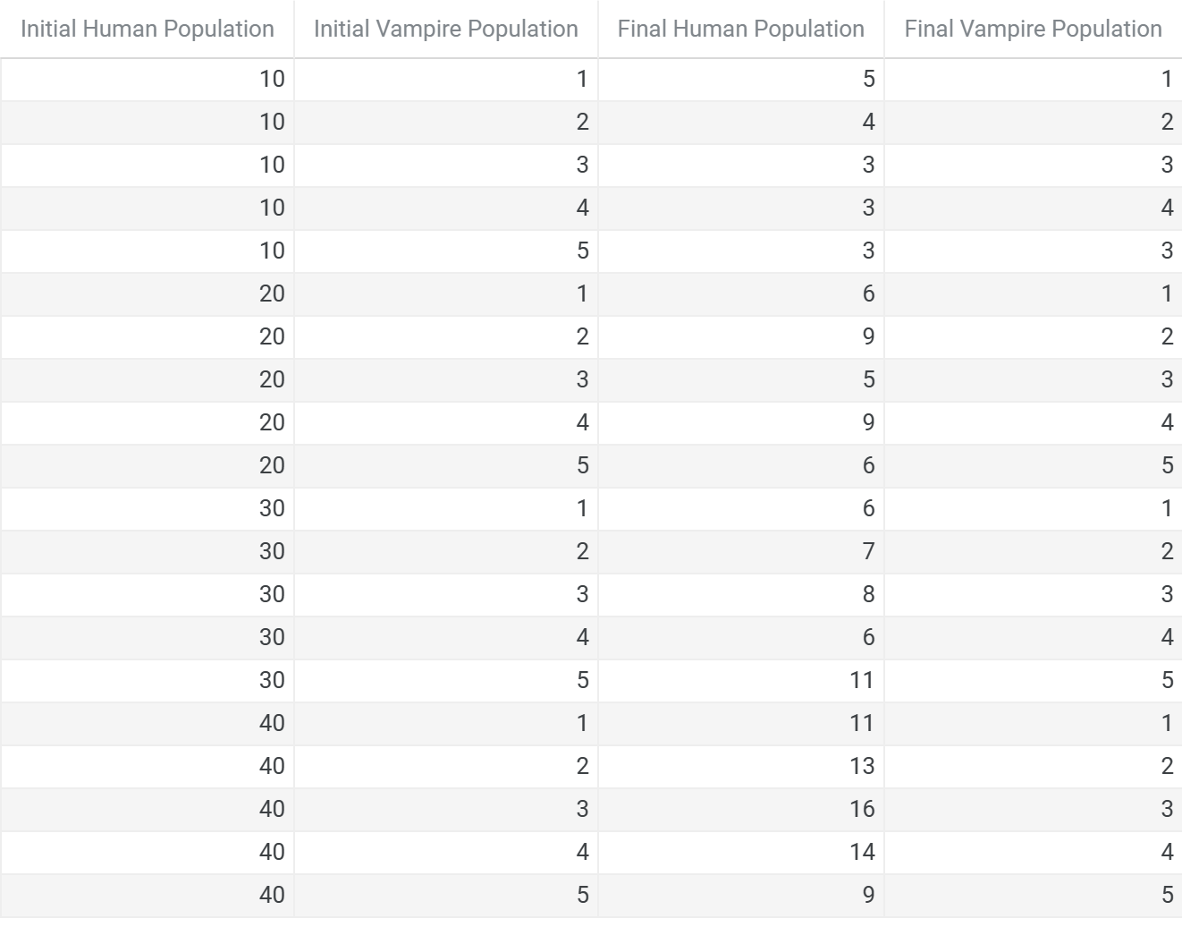
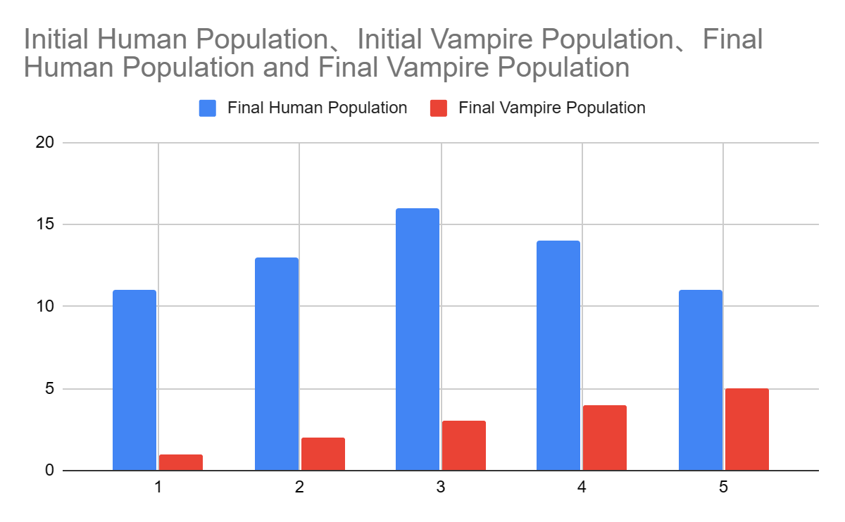
The results of our analysis show that the initial vampire population has a significant impact on the final human and vampire populations. As the initial vampire population increases, the final human population decreases and the final vampire population increases. This is expected as the higher the initial vampire population, the more opportunities there are for human infection.

In situations where the initial vampire population is low (1 or 2), the final human population is relatively high and the final vampire population is relatively low. However, as the initial vampire population increases to 3 or higher, the final human population drops significantly and the final vampire population increases correspondingly.

There are some situations where all humans do not become vampires. For example, when the initial human population is 30 and the initial vampire population is 1, the final human population is 6 and the final vampire population is 1. This is likely due to the small initial vampire population not having enough opportunities to infect all of the humans.

In general, these results suggest that controlling the initial vampire population is crucial in preventing a vampire takeover. The World Health Organisation can use this information to develop strategies for limiting the spread of the vampire virus and protecting the human population.

Conclusion and Future Work

The simulation program has provided valuable insights into the impact of initial vampire populations on the rate of human infection. The results of the simulation show that the initial vampire population has a significant impact on the rate of human infection, and that as the initial vampire population increases, the rate of human infection increases as well. In order to further investigate the dynamics of vampire infection among humans, the simulation could be expanded to include additional factors such as the human population density and vampire infection transmission rate.

References

Python Software Foundation. (n.d.). Python Programming Language. Retrieved from https://www.python.org/
Object-Oriented Programming in Python. (n.d.). Retrieved from https://www.tutorialspoint.com/python/python_classes_objects.htm

